**BUKI THRIFT WEBSITE PROJECT.**

* This is an e-commerce project entailing the selling of men’s shoes.
* The website is needed to be universal, therefore, the best URL for this website will be [www.bukithrift.com](http://www.bukithrift.com). – I have done my research, and no business/organization has claimed the URL.
* The website use will tend to update new stock, sold stock and stagnant stock.

SCHEMA FOR THE WEBSITE

* Members table – This table will be able to get anyone in the system, either a client or a database administrator.
* It will be able to specify which type of member you are when you sign up or login; of which, on the admin side, it would be integrated on the backend, therefore, it will automatically take you to the customers side.

1. 1.Email – PK; will be used as a foreign key in the admin and customer table, for relationship.
2. 2.Member password
3. 3.Member Type – either ‘customer’ or admin

* Customer table – This table will entail the details of the customers.
* It will be integrated with the members table, whereby when customer signs up, it will be updated in the members table to distinguish, which kind of member they are, in this case it will be ‘customer’.

1. 1.custid – This will be generated automatically, therefore no need for it to be on the sign-up form. - PK
2. First Name
3. 3.Last Name
4. Phone no – This will be used as a payment tool, where there will be payment integration. N/B also bank integration will be advised because it is a system to be also used outside Kenya.
5. Email – FK, this will act as a relationship with the members table to distinguish the member type.
6. Address
7. 6.Password.

* Admin table – This table entails the details of the administrator of the database.
* It will also be integrated with the members table, so as to distinguish the user to be the admin, where they can view everything / Update everything happening on the system.

1. 1.adminid – This will be input directly in the database so that the admin can use it when entering in the system, when need arises -PK
2. First Name
3. 3.Last Name
4. 4.Phone no
5. Email – FK; relationship between members table so that distinguish member type
6. 6.Password.

* Products table – This table entails the details about the products to be sold.
* This table should be used to update the new stock, update what stock has been sold, and which stock is not moving.

1. 1.Prodid – PK This should be generated automatically, and not shown from the customer’s view of the system, only the admin
2. 2.Productname
3. 3.Productimage
4. 4.Product size- Since this is a shoe website
5. 5.Product Price
6. 5.Description

* Orders table – This table entails the details about the orders made by a customer.
* This table should be able to view what product has been ordered by which customer.

1. Orderid – This should be generated automatically but should be able to be viewed by the customer so that they can track it during delivery.
2. Prodid – FK; This forms a relationship between the order and the products table, so that it can output all the details about the product that has been ordered.
3. Custid -FK; This forms a relationship between the order and the customer table, so that it can output all the details about the customer who has ordered.
4. Orderdate
5. Quantity
6. Order description.
7. Total

* Payments table – This table entails the payment details of the customer.
* This table world be integrated with the orders table for the payments.

1. Paymentid – generated automatically, but only viewed on the side of the admin. - PK
2. Orderid
3. Payment Method – This is where we will integrate MPESA and Bank Methods

* The UI of the website had been designed but that will not be its final look, just a design look to see what we are working with, HTML, CSS and JavaScript has been used.

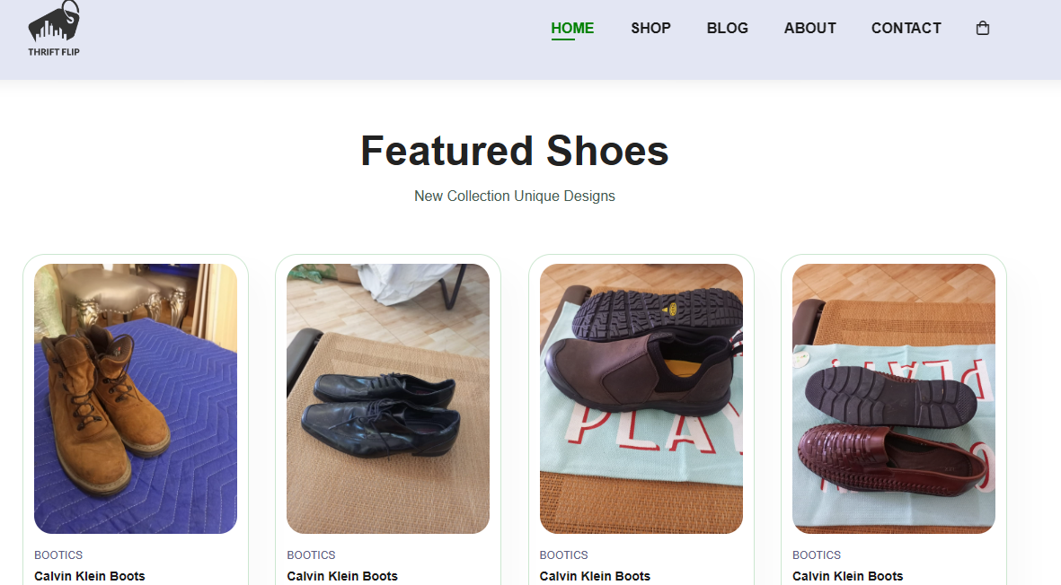

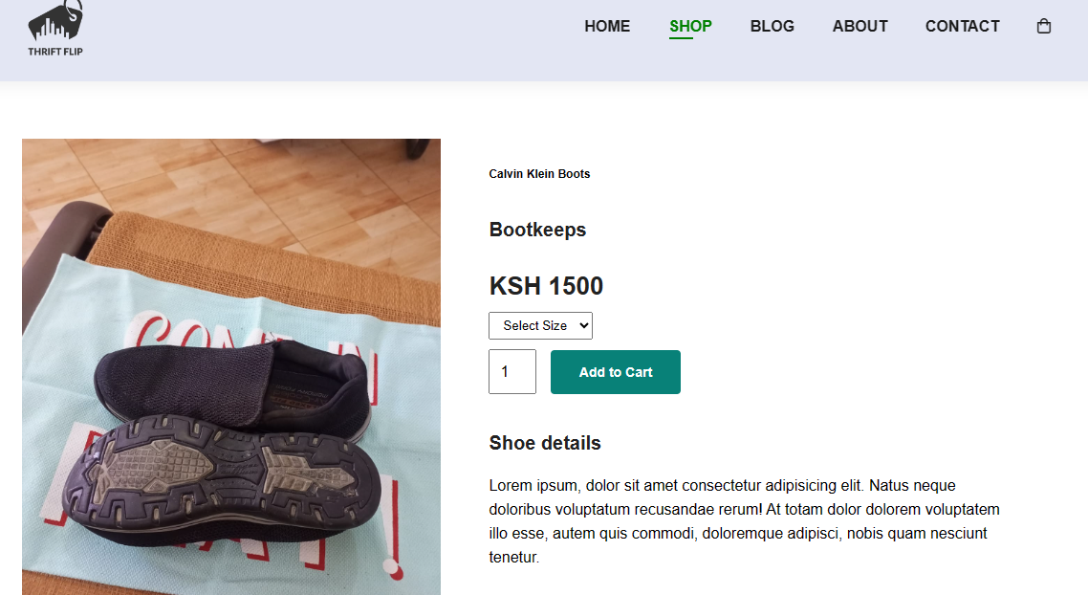

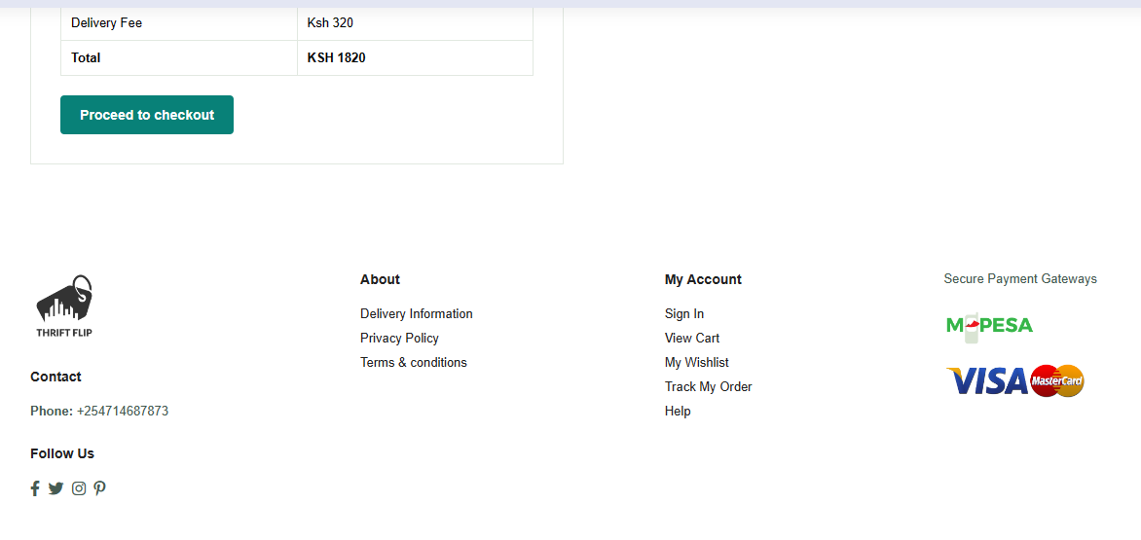

* This project is being done by Kimberly Kelsy and Stanely Okeyo, where;

1. Kimberly Kelsy – Project Manager, Frontend,
2. Stanely Okeyo – Backend.

**THIS DOCUMENT WAS PRODUCED BY KIMBERLY KELSY .**